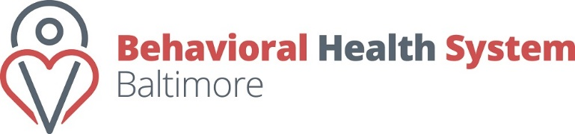
REQUEST FORM FOR LETTERS OF SUPPORT
Behavioral Health System Baltimore, Inc. (BHSB) accepts requests for letters of support from partners and community members for grant proposals and other projects. Complete this form and attach a draft letter. Send requests to Procurements@BHSBaltimore.org.
Please allow at least five business days for us to process your request.
CONTACT INFORMATION
Date of request: Click or tap here to enter text.
Date letter needed: Click or tap here to enter text.
Organization name: Click or tap here to enter text.
Contact name: Click or tap here to enter text.
Contact e-mail: Click or tap here to enter text.

Relationship to BHSB:
☐ Active Partner
☐ Active Contract Held
☐ No Formal Relationship
☐ Other: Click or tap here to enter text.

Are you asking BHSB to commit resources (e.g., staff time, funding)?
☐ No ☐ Yes (explain): Click or tap here to enter text.
Attach a draft Letter of Support that includes:
☐ Organizational contact information
☐ Description of the project
☐ BHSB’s involvement (if any)
☐ The benefit to the public behavioral health system

THANK YOU!

