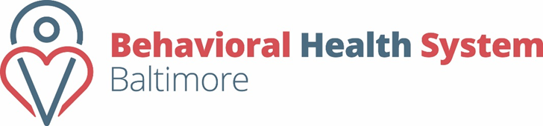  Division of Contract Operations  Contract Management System (CMS) Training Calendar | 2017

July  S M T W T F s  1  2 3 4 5 6 7 8  9 10 11 12 13 14 15  16 17 18 19 20 21 22  23 24 25 26 27 28 29  30 31 |  | August  S M T W T F s  1 2 3 4 5  6 7 8 9 10 11 12  13 14 15 16 17 18 19  20 21 22 23 24 25 26  27 28 29 30 31 |  | September  S M T W T F s  1 2  3 4 5 6 7 8 9  10 11 12 13 14 15 16  17 18 19 20 21 22 23  24 25 26 27 28 29 30
October  S M T W T F s  1 2 3 4 5 6 7  8 9 10 11 12 13 14  15 16 17 18 19 20 21  22 23 24 25 26 27 28  29 30 31 |  | November  S M T W T F s  1 2 3 4  5 6 7 8 9 10 11  12 13 14 15 16 17 18  19 20 21 22 23 24 25  26 27 28 29 30 |  | December  S M T W T F s  1 2  3 4 5 6 7 8 9  10 11 12 13 14 15 16  17 18 19 20 21 22 23  24 25 26 27 28 29 30  31
Afternoon

Monday’s 1:30P.M.- 3:00 P.M. Program Reporting

Wednesday’s 1:30P.M.-3:00P.M. Fiscal Reporting

Friday’s 1:30P.M.-3:00P.M. Program Reporting
Morning

Monday’s 10:00A.M.- 11:30A.M. Fiscal Reporting

Wednesday’s 9:00A.M.- 10:30A.M. Program Reporting

Friday’s 10:00A.M.-11:30A.M. Fiscal Reporting
Training Days are indicated in BLUE on the calendar above
All dates in RED BHSB Office- will be Closed
*Trainings are provided via Live Webinar*

