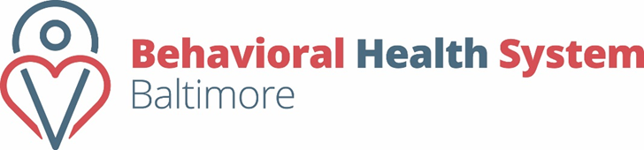  Division of Contract Operations  Electronic Signature (E-sign) Training Calendar | 2017

June
S | M | T | W | T | F | s
 |  |  |  | 1 | 2 | 3
4 | 5 | 6 | 7 | 8 | 9 | 10
11 | 12 | 13 | 14 | 15 | 16 | 17
18 | 19 | 20 | 21 | 22 | 23 | 24
25 | 26 | 27 | 28 | 29 | 30

July  S M T W T F s  1  2 3 4 5 6 7 8  9 10 11 12 13 14 15  16 17 18 19 20 21 22  23 24 25 26 27 28 29  30 31 |  | August  S M T W T F s  1 2 3 4 5  6 7 8 9 10 11 12  13 14 15 16 17 18 19  20 21 22 23 24 25 26  27 28 29 30 31 |  | September  S M T W T F s  1 2  3 4 5 6 7 8 9  10 11 12 13 14 15 16  17 18 19 20 21 22 23  24 25 26 27 28 29 30
*Trainings are provided via Live Webinar*

Tuesday’s 11:00A.M.- 12:00P.M

Thursday’s 1:30P.M.- 2:30P.M.

Friday’s 10:00A.M.-11:00A.M
Training Days are indicated in BLUE on the calendar above
All dates in RED BHSB Office- will be Closed

